

# Car Rental System

|  |  |  |
| --- | --- | --- |
| **Supervisor:** | *LÊ THANH NHÂN* |  |
| **Semester:** | *II* |  |
| **Batch No:** | *T1.2010.E0* |  |
| **Group No:** | *04* |  |
| **Order:** | **Full name** | **Roll No.** |
| *1.* | *Lưu Quang Nhật* | *Student1620955* |
| *2.* | *Nguyễn Anh Đức* | *Student1620949* |
| *3.* | *Hoàng Anh Đức* | *Student1623038* |
| *4.* | *Nguyễn Võ Minh Tuấn* | *Student1623646* |

***Month****: 08* ***Year****: 2021*



This is to certify that

|  |  |
| --- | --- |
| **Mr.** | **Lưu Quang Nhật** |
| **Mr.** | **Nguyễn Anh Đức** |
| **Mr.** | **Hoàng Anh Đức** |
| **Mr.** | **Nguyễn Võ Minh Tuấn** |

Have successfully Designed & Developed

**CAR RENTAL SYSTEM**

Submitted by:

**Mr. LE THANH NHAN**

Date Of Issue:

Authorized Signature:

**Content**

**Acknowledgement** Page 04

**Synopsis** Page 05

**Review 1** Page 06

*Problem Definition* Page 07

*Customer Requirement Specifications* Page 09

**Review 2** Page 12

*Data Flow Diagram* Page 13

*Entity Relationship Diagram* Page 14

*Table Design* Page 20

*Site Map* Page 24

*Algorithm* Page 25

**Review 3** Page 28

*Screenshot* Page 29

*Testing Documents* Page 60

*Final Checklist* Page 61

**Task Sheet** Page 62

**Acknowledgement**

Firstly, we would like to express our sincere gratitude to our teacher Mr. Le Thanh Nhan for giving us the opportunity to conduct this project as well as the support and guidance he provided throughout the project so that it would be completed promptly and with high efficiency. This project is a simulation of a real-life workplace where we have to work as a team to develop a website to meet the requirements of our client. The project helped us to learn more about teamwork, coordination, self-motivation as well as our overall skill improvement in the field of website development.

Secondly, we would like to give our thanks to the team member of group 4, without whom this project could not have been realized. The teamwork and the enthusiasm of the member have brought life to the project. Each member has utilized his skill and knowledge in the field of website development, putting aside their differences to coordinate with each other in a highly efficient manner to achieve our common goal.

We hope that after this project, each team member will have gained invaluable experiences on how website development in real life is conducted, which serve as the first stepping stones for us to start our jobs after graduation. We also hope that the team will continue to improve their skills and knowledges to become successful in a highly competitive and ever-changing industry.

Last but not least we are very thankful to FPT Aptech HCMC, Aptech India and our family members for your continuous and indispensable supports on various aspect of our lives. We will make sure to make this project a great success as the way to show gratitude to everyone.

Yours sincere,

Members of Group 4.

**Synopsis**

The objective Car Rental System project is to create a framework for a website of a company whose main business is rental service. Using the website, customers could browse and rent different items. On the management side, the administrative staff could receive rental orders, input data and extracting reports on a variety of involving entities. In addition, the implementation of the website also facilitates the process of car/driver deployment and management.

The project aims to create a simulation of a real-life project development process, and set a fundamental understanding on Java and PHP for the students in Semester II to develop larger and more complex projects in the future. The students are expected to utilize the knowledge they have acquired during class and from self-study for the project.

The entire project was conducted under the supervision of Mr. Le Thanh Nhan and should only be used for academic purposes.

# Review 01

**Problem Definition**

Deluxe Rentals Co. Ltd. is an emerging name in the car rental service industries. The company provides rental vehicles from various brands and types that meet the requirements and expectations of even the most demanding clients.

Owning a garage that has the capabilities to provide services to 50 cars at once, all the company vehicles are always in the best conditions and readied to be delivered to our clients. The management staff is also professionally trained to make sure that all of the client’s needs are provided, and they always try to find new ways to please the clients.

In addition to that, our driver staff which is strictly and carefully selected will ensure safe and pleasant travel throughout the journey. All the drivers, vehicles and clients are fully covered with insurance and all legal and safety requirements are met.

Deluxe Rentals has become more and more popular with a sharp increase in sales after only 1 year of establishment. In order to efficiently manage the rental orders as well as providing a convenient, easy-to-use platform of booking for the clients, the company decided to develop a website which provides the following functions to the clients:

* Provide member registration feature. After registration, the clients could start booking rental cars.
* Provide information of the rental vehicles to clients and members.
* Provide shopping cart function to book multiple vehicles at once.
* Receive feedbacks from clients and members to improve service quality as well as product quality.

On the administration side, the website includes an Admin Control Panel (ACP) that supports the following management functions:

* Provide the functions to manage records of clients, staff, vehicles.
* Provide the function to check booking details.
* Provide the function to view reports.

**The Role of User, Staff and Admin:**

1. **User:**
   * Can register as a member and manage personal account.
   * Can view and booking vehicles.
   * Can give feedback regarding the service.
   * Can view their orders.
2. **Staff:**
   * Can view client/vehicle information
   * Can check contract details.
   * Can reply to feedback of clients.
3. **Administrator:** Same roles as staff but with the following additions:
   * Can view/ add / edit / delete records of clients, staff, vehicles.
   * Can view report statistics.

**Customer Requirement Specifications**

Description of the processing requirements for each target user.

1. **Clients:**

**❖ Input:**

* Member registration information.
* Request vehicle information.
* Book selected vehicles.
* Feedback about the service.

**❖ Process:**

* Process customer registration information.
* Search vehicles from database by brand, by type.
* Process client orders.
* Process client feedback.

**❖ Output:**

* Notification of successful registration.
* Display vehicle information.
* Notification of successful order booking.
* Notification of successful feedback submission.

1. **Management Staff:**

**❖ Input:**

* Staff/Administrator login information.
* Client, vehicle, staff information to add / edit / delete. (Admin only)
* Member/order information to be display.

**❖ Process:**

* Processing login information.
* Add / edit / delete client, vehicle, staff information.
* Search member/order information.

**❖ Output:**

* Notification of successful login.
* Notification of success/ failure for the addition / edit / deletion of client, vehicle, staff information.
* Display member/order information.

**Hardware / Software requirement**

|  |  |  |
| --- | --- | --- |
| **No.** | **Item** | **Description** |
| 1. | Operating system | Windows 7 or higher |
| 2. | Hardware | CPU Cores or better with 2 Gigabytes of RAM or better |
| 3. | Web Browser | Version in later of: Edge, Firefox, Chrome |
| 4. | Fonts | Standard font Unicode: Arial, Tahoma, Lucida Console, Times New Roman |
| 5. | Other requirements | Laravel, Git, XAMPP 7.3 or later | A working internet connection. |

# Review 02

**Data Flow Diagram**

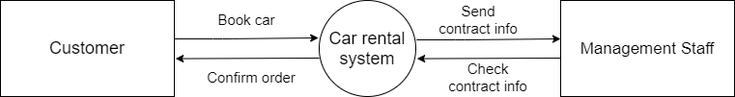

**Entity Relationship Diagram**

1. **ERD**

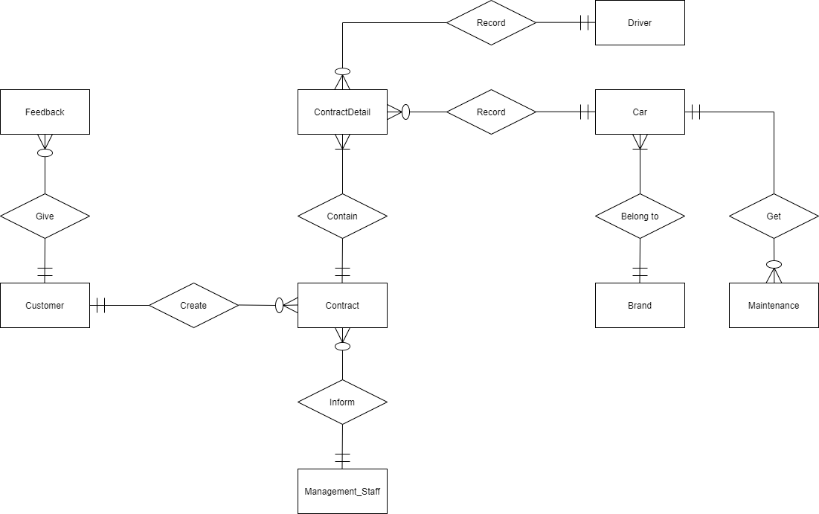

1. **ERD Properties**
2. **Customer**

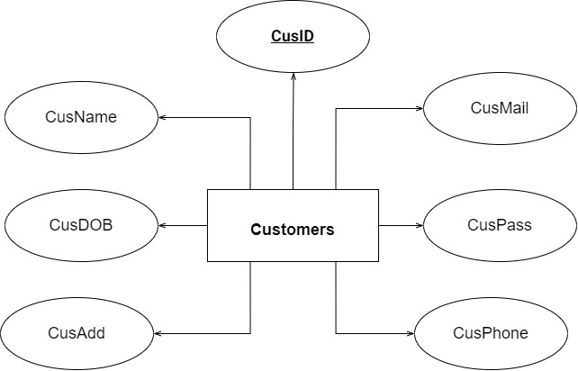

1. **Car**

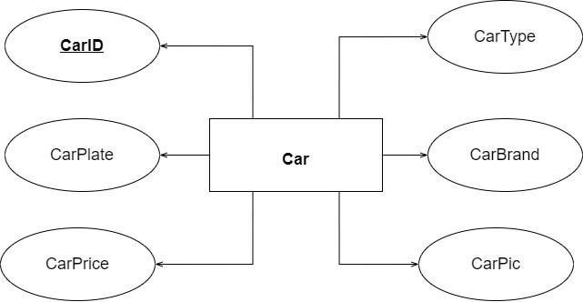

1. **Driver**

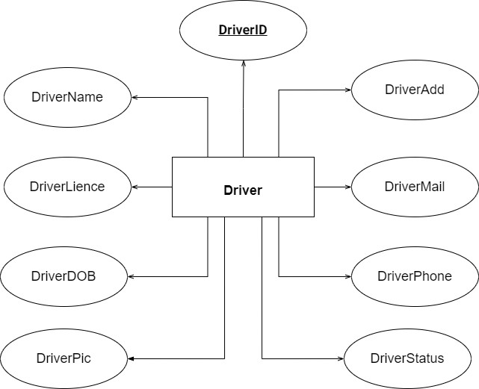

1. **Management Staff**

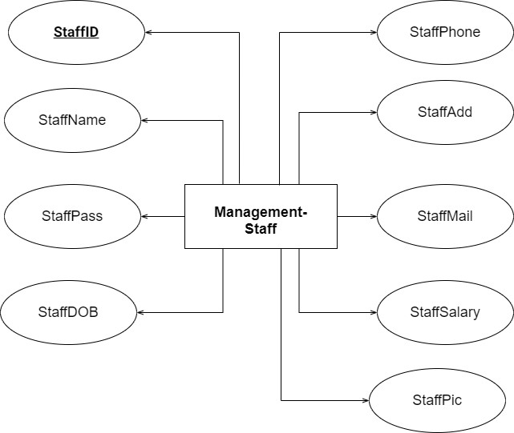

1. **Feedback**

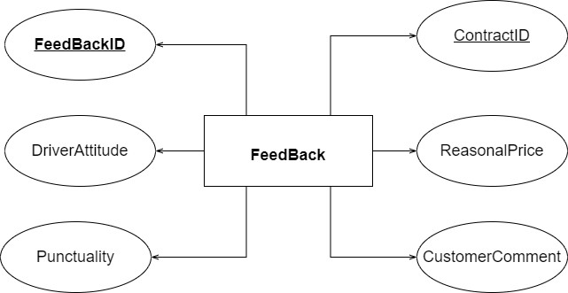

1. **Contract**

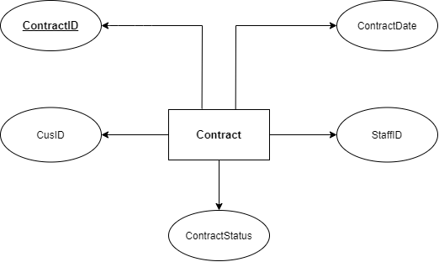

1. **Contract Detail**

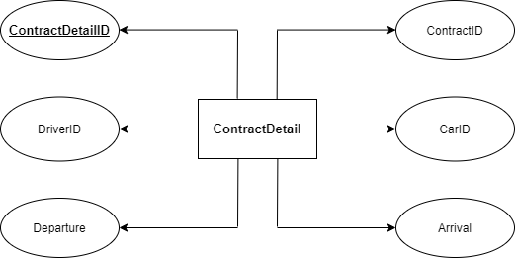

1. **Brand**

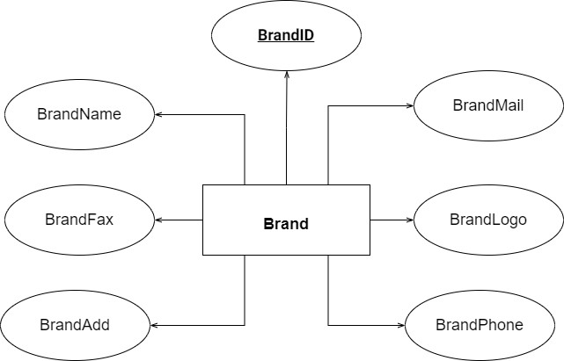

1. **Maintenance**

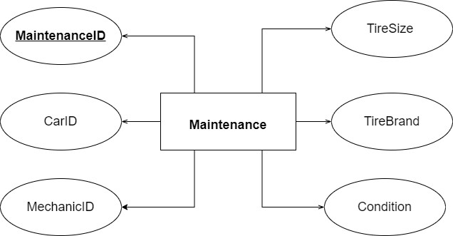

**Table Design**

**A. Table Design**

|  |  |  |  |  |  |
| --- | --- | --- | --- | --- | --- |
| **01. Customer** | | | | | |
| **No.** | **Fields** | **Data Type** | **Key** | **Constrain** | **Description** |
| 1. | CusID | varchar(20) | Primary | Not null | Customer ID number |
| 2. | CusName | varchar(50) |  | Not null | Customer name |
| 3. | CusDOB | date |  | Not null | Customer birthday |
| 4. | CusAdd | varchar(255) |  | Not null | Customer address |
| 5. | CusMail | varchar(50) |  | Not null, Mail format | Customer mail |
| 6. | CusPass | varchar(20) |  | Not null, 8-20 characters | Customer login password |
| 7. | CusPhone | int |  | Not null | Customer phone no. |

|  |  |  |  |  |  |
| --- | --- | --- | --- | --- | --- |
| **02. Car** | | | | | |
| **No.** | **Fields** | **Data Type** | **Key** | **Constrain** | **Description** |
| 1. | CarID | varchar(20) | Primary | Not null | Car ID number |
| 2. | CarPlate | varchar(10) |  | Not null | Car plate number |
| 3. | CarPrice | int |  | Not null | Rental price/day |
| 4. | CarType | varchar(20) |  | Not null | Number of seats |
| 5. | CarBrand | varchar(20) |  | Not null | Car brand |
| 6. | CarPic | varchar(255) |  | Not null | Car picture |

|  |  |  |  |  |  |
| --- | --- | --- | --- | --- | --- |
| **03. Driver** | | | | | |
| **No.** | **Fields** | **Data Type** | **Key** | **Constrain** | **Description** |
| 1. | DriverID | varchar(20) | Primary | Not null | Driver ID number |
| 2. | DriverName | varchar(50) |  | Not null | Driver name |
| 3. | DriverLicense | varchar(20) |  | Not null | Driver driving license |
| 4. | DriverDOB | date |  | Not null | Driver birthday |
| 5. | DriverPic | varchar(255) |  | Not null | Driver picture |
| 6. | DriverAdd | varchar(255) |  | Not null | Driver address |
| 7. | DriverMail | varchar(50) |  | Not null, Mail format | Driver email |
| 8. | DriverPhone | int |  | Not null | Driver phone |
| 9. | DriverStatus | boolean |  | Not null | Available or not |
| 10. | CurrentDriver | boolean |  | Not null | Current driver or not |

|  |  |  |  |  |  |
| --- | --- | --- | --- | --- | --- |
| **04.** **Management Staff** | | | | | |
| **No.** | **Fields** | **Data Type** | **Key** | **Constrain** | **Description** |
| 1. | StaffID | varchar(20) | Primary | Not null | Staff ID number |
| 2. | StaffName | varchar(50) |  | Not null | Staff name |
| 3. | StaffPass | varchar(20) |  | Not null, 8-10 characters | Staff login password |
| 4. | StaffDOB | date |  | Not null | Staff birthday |
| 5. | StaffPhone | int |  | Not null | Staff phone |
| 6. | StaffAdd | varchar(255) |  | Not null | Staff address |
| 7. | StaffMail | varchar(50) |  | Not null, Mail format | Staff email |
| 8. | StaffSalary | int |  | Not null | Staff salary |
| 9. | StaffPic | varchar(255) |  | Not null | Staff picture |
| 10. | CurrentStaff | boolean |  | Not null | Current staff or not |

|  |  |  |  |  |  |
| --- | --- | --- | --- | --- | --- |
| **05. Feedback** | | | | | |
| **No.** | **Fields** | **Data Type** | **Key** | **Constrain** | **Description** |
| 1. | FeedbackID | varchar(20) | Primary | Not null | Feedback ID number |
| 2. | ContractID | varchar(20) | Foreign | Not null | Contract ID number |
| 3. | CusID | varchar(20) | Foreign | Not null | Customer ID number |
| 4. | DriverAttitude | int |  | Not null, 1-5 | Driver attitude rating |
| 5. | Punctuality | int |  | Not null, 1-5 | Punctuality rating |
| 6. | ReasonalPrice | int |  | Not null, 1-5 | Price rating |
| 7. | Comment | varchar(255) |  | Not null, 1-5 | Customer’s comment |

|  |  |  |  |  |  |
| --- | --- | --- | --- | --- | --- |
| **06. Contract** | | | | | |
| **No.** | **Fields** | **Data Type** | **Key** | **Constrain** | **Description** |
| 1. | ContractID | varchar(20) | Primary | Not null | Contract ID number |
| 2. | ContractDate | date |  | Not null | Contract date |
| 3. | CusID | varchar(20) | Foreign | Not null | Customer ID number |
| 4. | StaffID | varchar(20) | Foreign | Not null | Staff ID number |
| 5. | ContractStatus | boolean |  | Not null | Complete or not |

|  |  |  |  |  |  |
| --- | --- | --- | --- | --- | --- |
| **07. Contract Details** | | | | | |
| **No.** | **Fields** | **Data Type** | **Key** | **Constrain** | **Description** |
| 1. | ContractDetailID | varchar(20) | Primary | Not null | Contract details ID number |
| 2. | ContractID | varchar(20) | Foreign | Not null | Contract ID number |
| 3. | DriverID | varchar(20) | Foreign | Not null | Driver ID number |
| 4. | CarID | varchar(20) | Foreign | Not null | Car ID number |
| 5. | Departure | date |  | Not null | Date of departure |
| 6. | Arrival | date |  | Not null | Date of arrival |

|  |  |  |  |  |  |
| --- | --- | --- | --- | --- | --- |
| **08. Brand** | | | | | |
| **No.** | **Fields** | **Data Type** | **Key** | **Constrain** | **Description** |
| 1. | BrandID | varchar(20) | Primary | Not null | Brand ID number |
| 2. | BrandName | varchar(20) |  | Not null | Brand name |
| 3. | BrandAdd | varchar(255) |  | Not null | Brand address |
| 4. | BrandFax | int |  | Not null | Brand fax number |
| 5. | BrandPhone | int |  | Not null | Brand phone |
| 6. | BrandMail | varchar(50) |  | Not null, Mail format | Brand email |
| 7. | BrandLogo | varchar(255) |  | Not null | Brand logo |

|  |  |  |  |  |  |
| --- | --- | --- | --- | --- | --- |
| **09. Maintenance** | | | | | |
| **No.** | **Fields** | **Data Type** | **Key** | **Constrain** | **Description** |
| 1. | MaintenanceID | varchar(20) | Primary | Not null | Maintenance ID number |
| 2. | CarID | varchar(20) | Foreign | Not null | Car ID number |
| 3. | Date | date |  | Not null | Maintenance date |
| 4. | Comment | varchar(255) |  | Not null | Comment on car condition |

**B. Relationship Diagram**

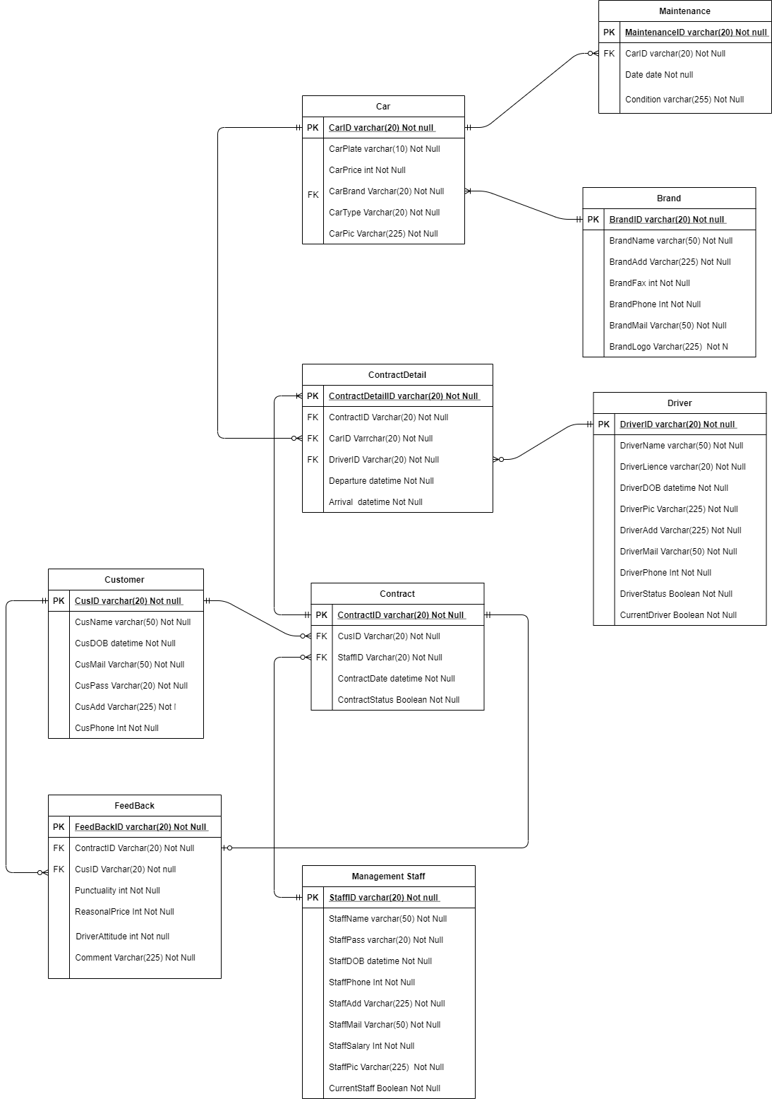

**Site Map**

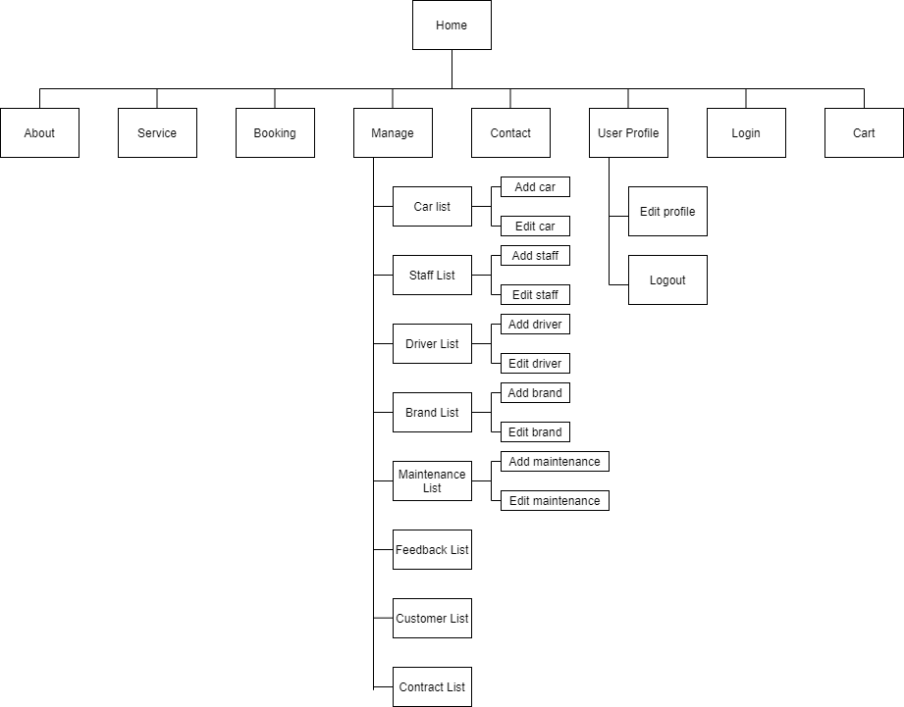

**Algorithm**

1. **Admin**

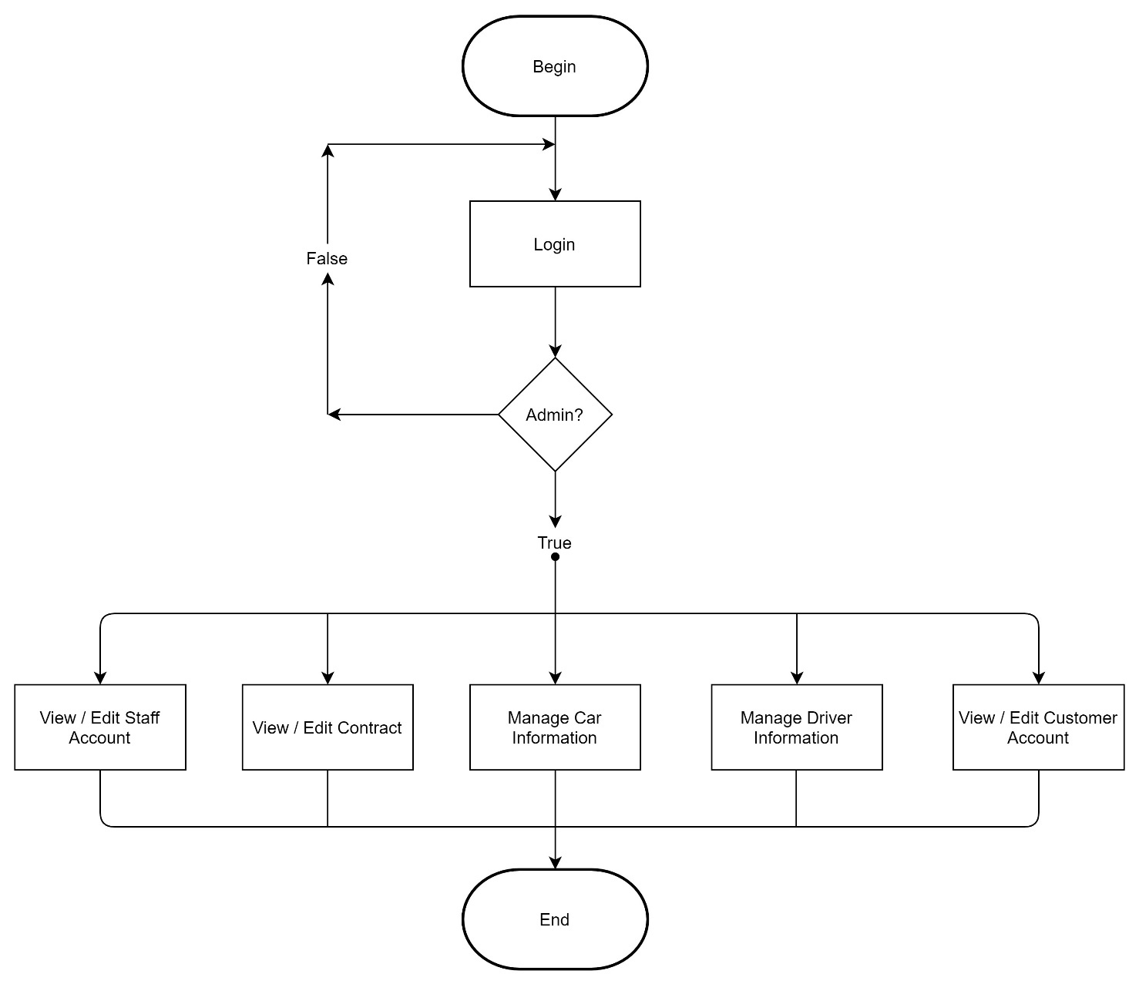

**B.B. Staff**

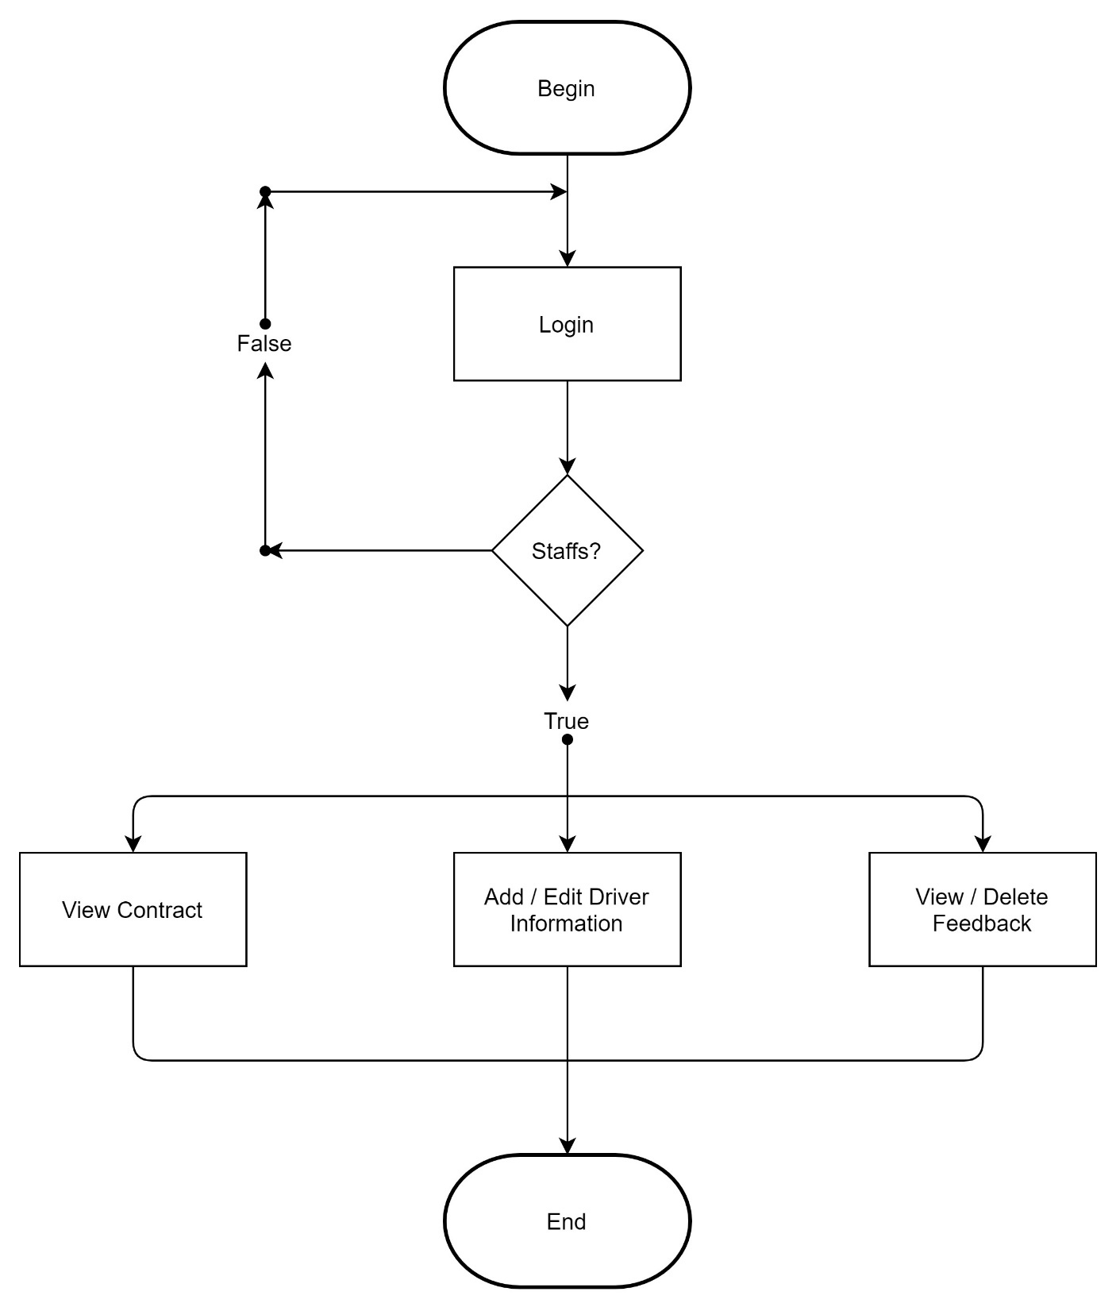

**C. Customer**

**B.**

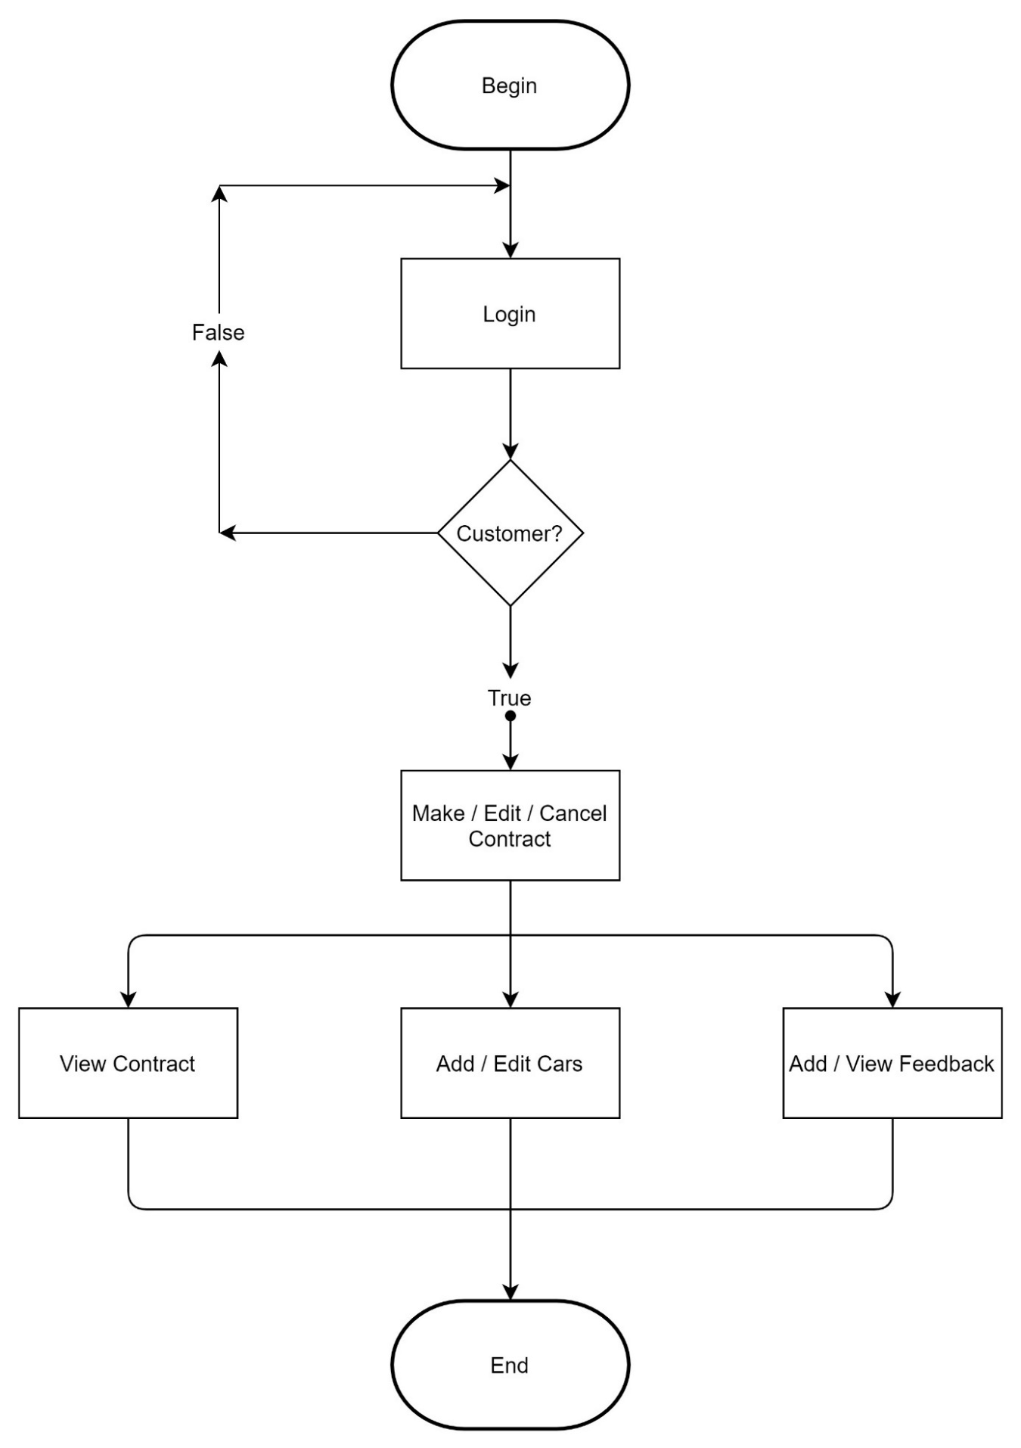

# Review 03

**Screenshot**

1. **Homepage**

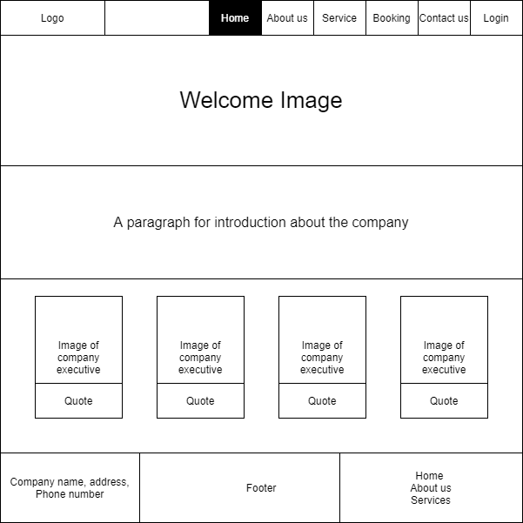

**Description:** Homepage of the company

**From: [**Home] button on navigation bar

**To:** About us, Service, Booking, Contact us, Login

1. **About us**

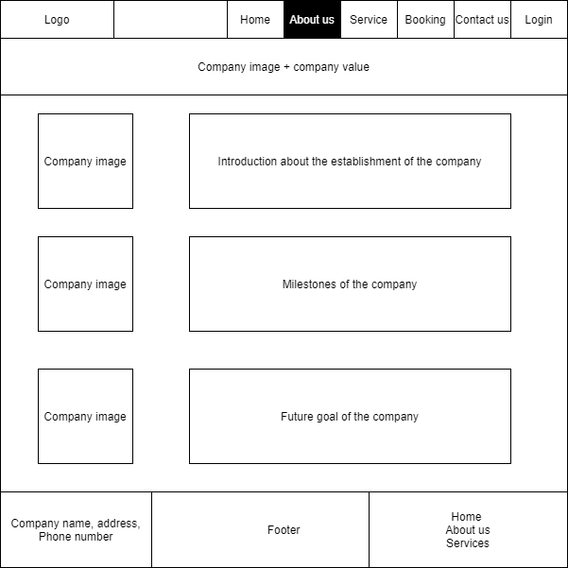

**Description:** Information about the company

**From: [**About us] button on navigation bar

**To:** Home, Service, Booking, Contact us, Login

1. **Service**

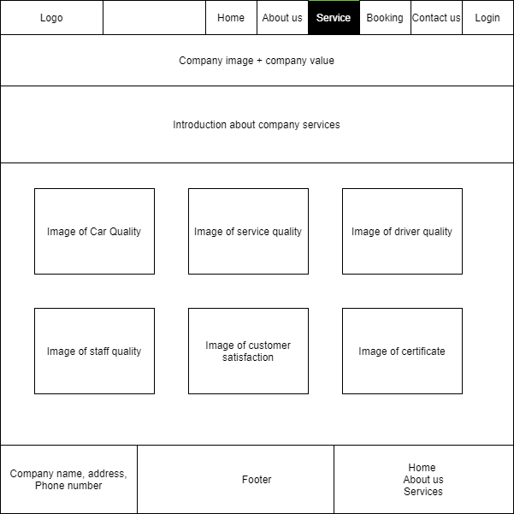

**Description:** Introduction of the company’s service

**From: [**Service] button on navigation bar

**To:** Home, About us, Booking, Contact us, Login

1. **Contact us**

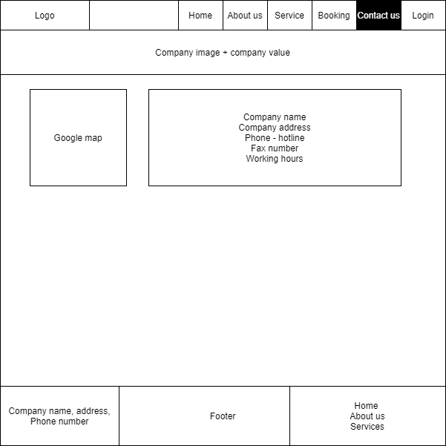

**Description:** Contact information of the company

**From: [**Contact us] button on navigation bar

**To:** Home, About us, Service, Booking, Login

1. **Login**

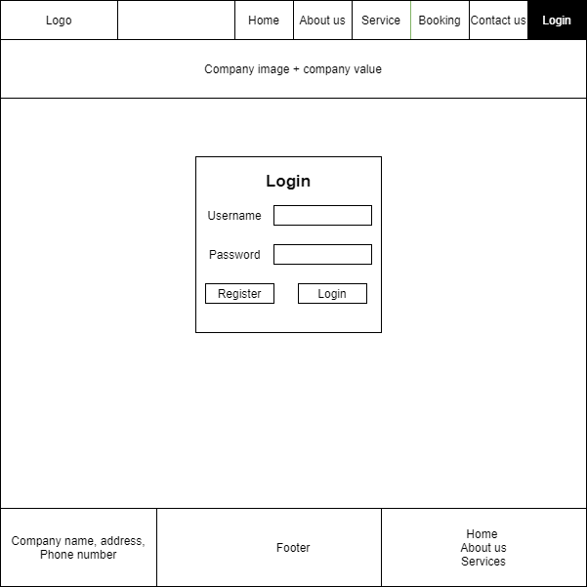

**Description:** Screen for customer, staff and admin to login

**From: [**Login] button on navigation bar, or [Booking] button without logging in

**To:** Home, About us, Service, Booking, Contact us, Register

**Validate:** Username and password must match the one registered in database.

1. **Booking**

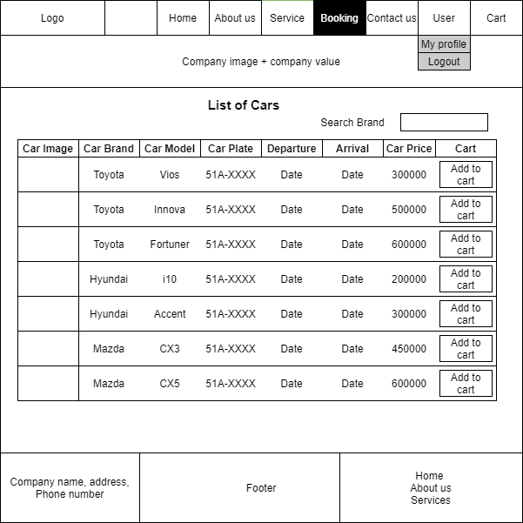

**Description:** Screen for customer to book cars

**From: [**Booking] button on navigation bar. Must login as customer.

**To:** Home, About us, Service, Contact us, User Profile, Logout, Cart

**Validate:** Arrival must after arrival when clicking on [Add to cart]

1. **Cart**

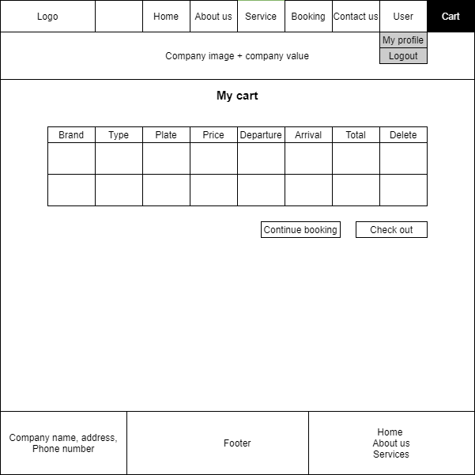

**Description:** Screen for customer to checkout the cart

**From: [**Cart] button on navigation bar. Must login as customer.

**To:** Home, About us, Service, Contact us, User Profile, Logout, Cart

1. **Checkout**

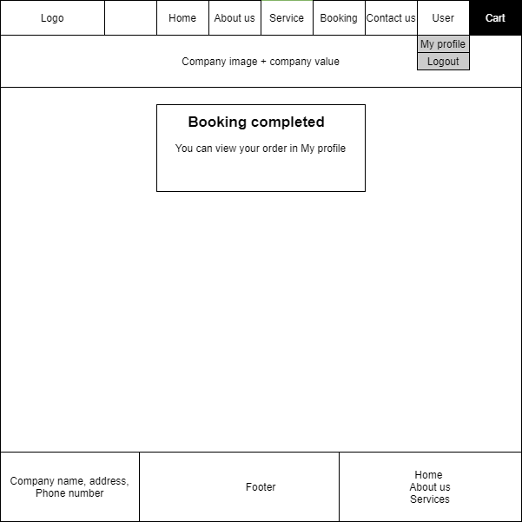

**Description:** Booking completed notice

**From: [**Checkout] button from [Cart] page

**To:** Home, About us, Service, Booking, Contact us, User Profile, Logout, Cart

1. **User Profile**

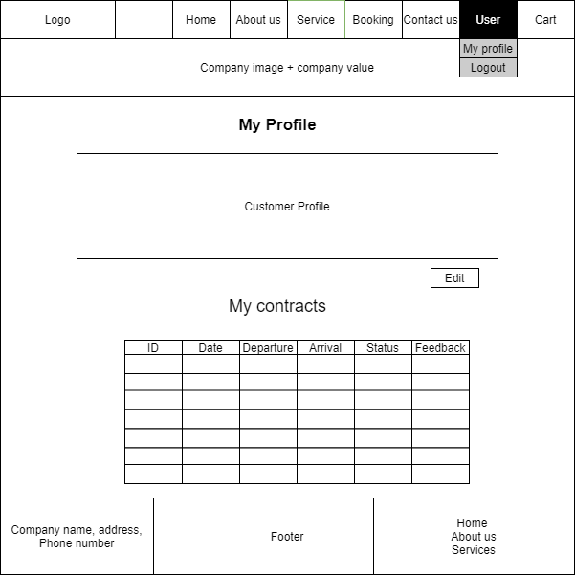

**Description:** Customer can see their information and orders

**From: [**My Profile] button from dropdown menu of [User] button of navigation bar

**To:** Home, About us, Service, Booking, Contact us, Logout, Cart, Edit User Profile

1. **Edit User Profile**

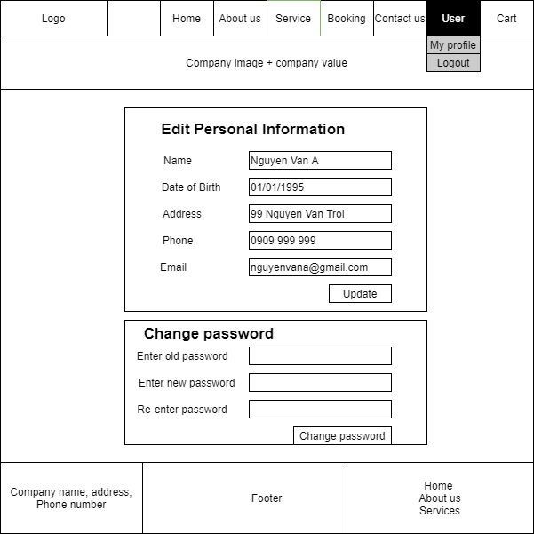

**Description:** Customer can edit their information

**From:** [Edit] button from [My Profile] page

**To:** Home, About us, Service, Booking, Contact us, My Profile, Logout, Cart

**Validation:** Email format, old password must be correct, new password must be entered 2 times and must match.

1. **Registration**

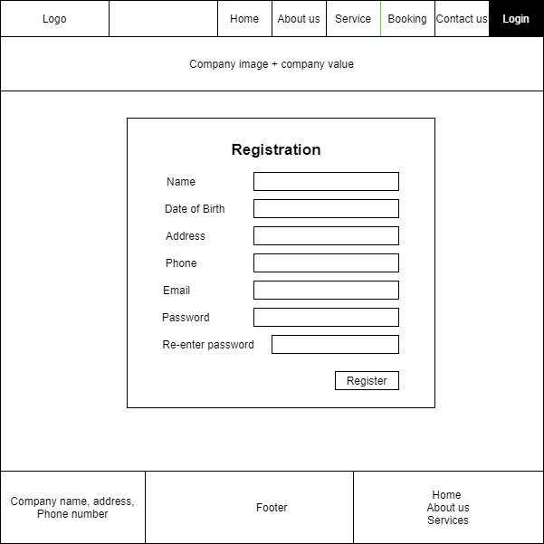

**Description:** Customer can register for membership

**From:** [Registration] button from [Login] page

**To:** Home, About us, Service, Booking, Contact us, Registration Completed.

1. **Registration Completed**

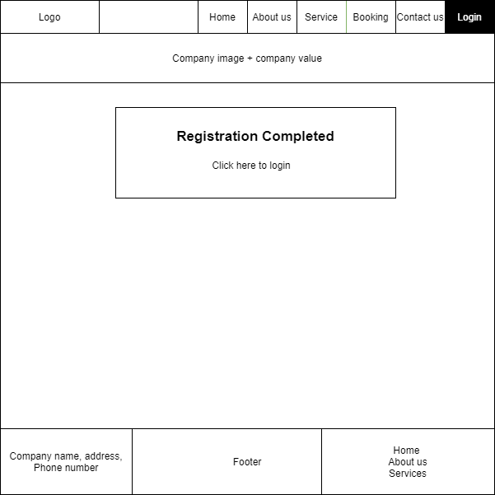

**Description:** Notification for registration completed

**From:** [Register] button from [Registration] page

**To:** Home, About us, Service, Booking, Contact us, Login

1. **Manage**

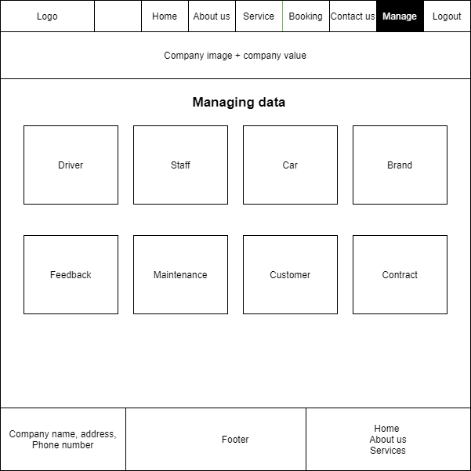

**Description:** Dashboard for the staff to manage system data

**From:** [Manage] button on navigation bar after login as admin or staff

**To:** Home, About us, Service, Booking, Contact us, Driver List, Staff List, Car List, Brand List, Feedback List, Maintenance List, Customer List, Contract List.

1. **Car List**

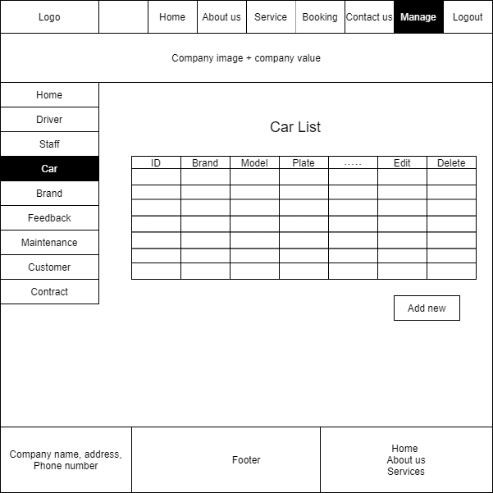

**Description:** Display list of cars

**From:** [Car] button from [Manage] Page

**To:** Home, About us, Service, Booking, Contact us, Driver List, Staff List, Brand List, Feedback List, Maintenance List, Customer List, Contract List, Car List, Create Car, Edit Car

1. **Create Car**

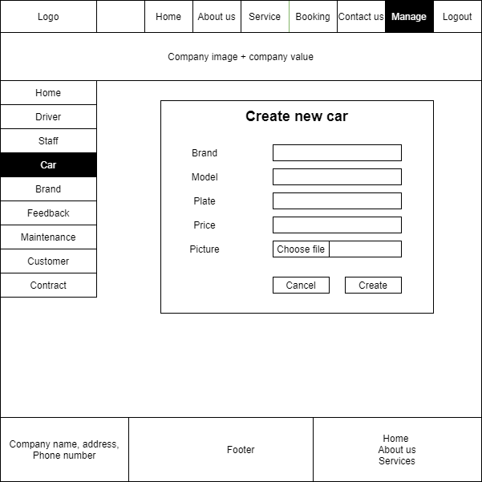

**Description:** Create a new information of car

**From: [**Add new] button under the [Car List] table

**To:** Home, About us, Service, Booking, Contact us, Driver List, Staff List, Brand List, Feedback List, Maintenance List, Customer List, Contract List, Car List

**Validate:** Brand must be selected from brand list

1. **Edit Car**

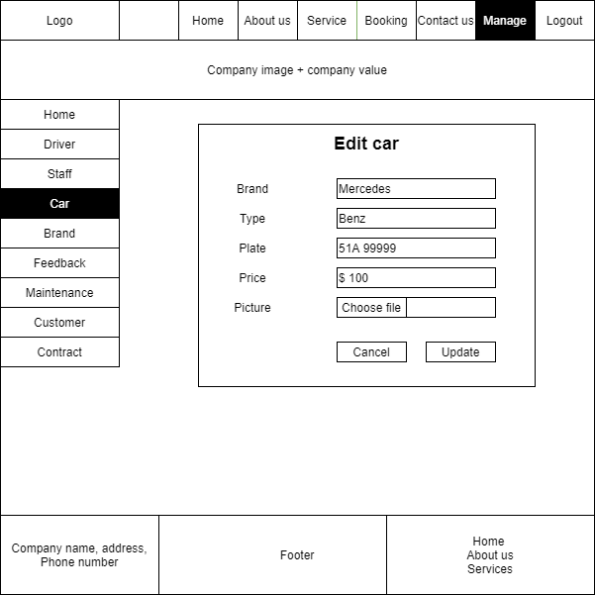

**Description:** Edit an information of car that has been added before

**From: [**Edit] button on [Car List] table

**To:** Home, About us, Service, Booking, Contact us, Driver List, Staff List, Brand List, Feedback List, Maintenance List, Customer List, Contract List, Create Car, Car List

**Validate:** Brand must be selected from brand list

1. **Driver List**

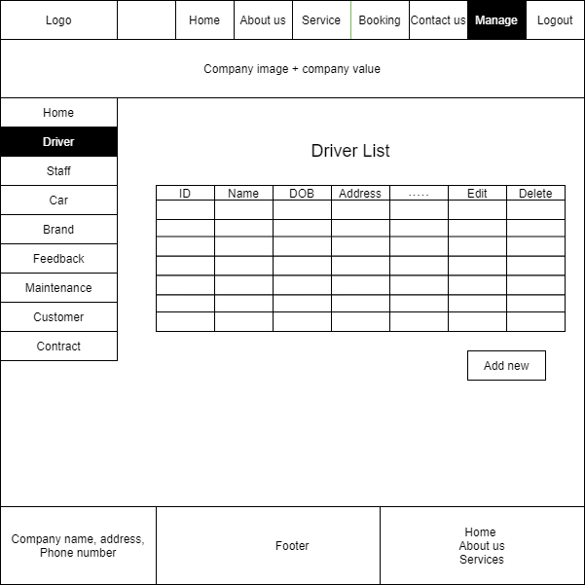

**Description:** Display the list of Drivers

**From: [**Driver] button from [Manage] Page

**To:** Home, About us, Service, Booking, Contact us, Driver List, Staff List, Brand List, Feedback List, Maintenance List, Customer List, Contract List, Car List, Create Driver, Edit Driver

1. **Create Driver**

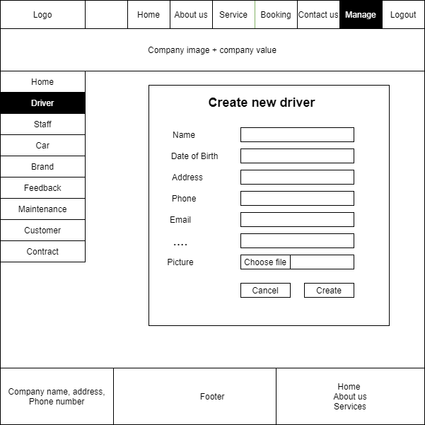

**Description:** Create a new information of driver

**From: [**Add new] button under the Driver List table

**To:** Home, About us, Service, Booking, Contact us, Driver List, Staff List, Brand List, Feedback List, Maintenance List, Customer List, Contract List, Car List

1. **Edit Driver**

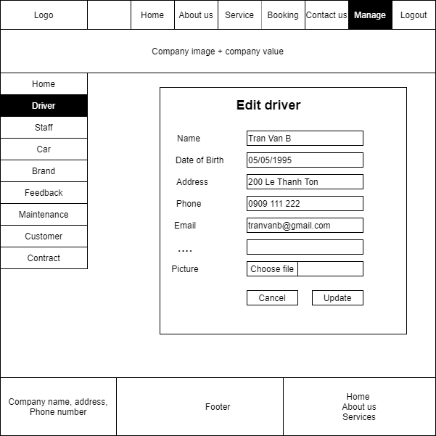

**Description:** Edit an information of driver that has been added before

**From: [**Edit] button on [Driver List] table

**To:** Home, About us, Service, Booking, Contact us, Driver List, Staff List, Brand List, Feedback List, Maintenance List, Customer List, Contract List, Car List

1. **Staff List**

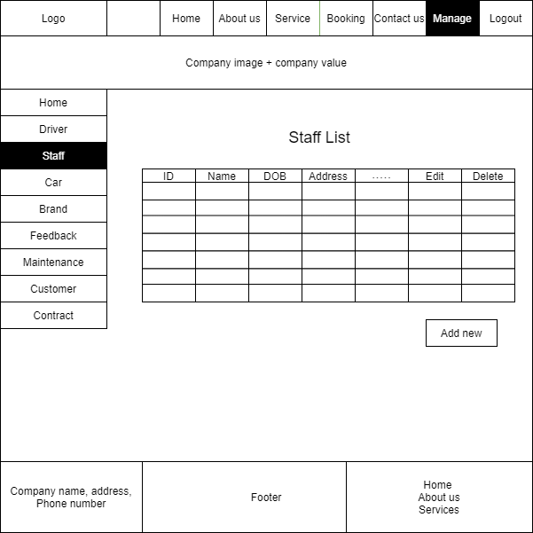

**Description:** Display the list of Staff

**From: [**Staff] button from [Manage] Page

**To:** Home, About us, Service, Booking, Contact us, Driver List, Staff List, Brand List, Feedback List, Maintenance List, Customer List, Contract List, Car List, Edit Staff, Create Staff

1. **Create Staff**

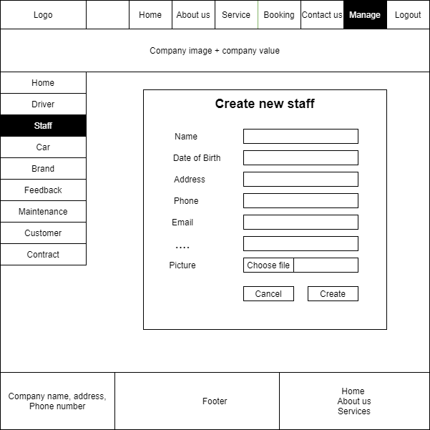

**Description:** Create a new information of staff

**From: [**Add new] button under the [Staff List] table

**To:** Home, About us, Service, Booking, Contact us, Driver List, Staff List, Brand List, Feedback List, Maintenance List, Customer List, Contract List, Car List

1. **Edit Staff**

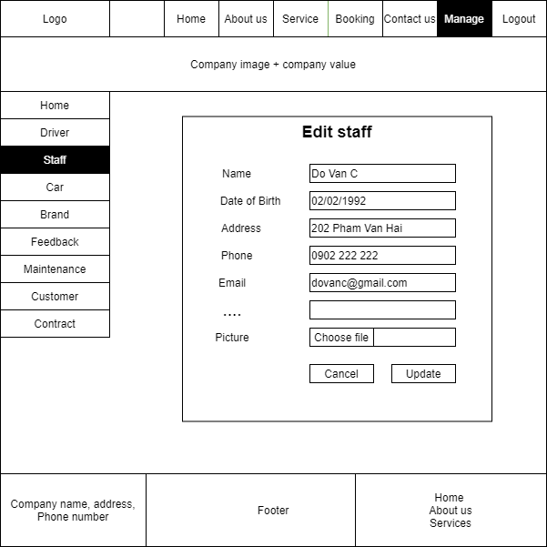

**Description:** Edit an information of staff that has been added before

**From: [**Edit] button on [Staff List] table

**To:** Home, About us, Service, Booking, Contact us, Driver List, Staff List, Brand List, Feedback List, Maintenance List, Customer List, Contract List, Car List

1. **Brand List**

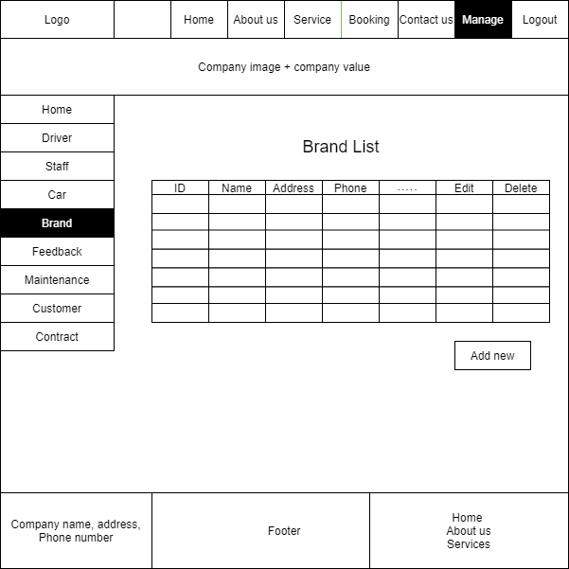

**Description:** Display the list of Brand

**From:** [Brand] button from [Manage] Page

**To:** Home, About us, Service, Booking, Contact us, Driver List, Staff List, Brand List, Feedback List, Maintenance List, Customer List, Contract List, Car List, Create Brand, Edit Brand

1. **Create Brand**

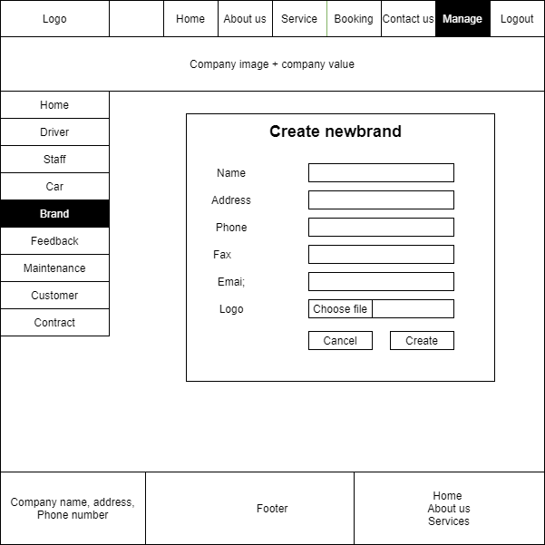

**Description:** Create a new information of brand

**From:** [Add new] button under the [Brand List] table

**To:** Home, About us, Service, Booking, Contact us, Driver List, Staff List, Brand List, Feedback List, Maintenance List, Customer List, Contract List, Car List

1. **Edit Brand**

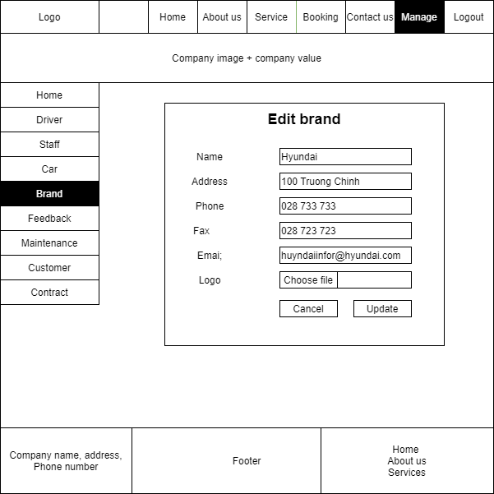

**Description:** Edit an information of brand that has been added before

**From:** [Edit] button on Brand List table

**To:** Home, About us, Service, Booking, Contact us, Driver List, Staff List, Brand List, Feedback List, Maintenance List, Customer List, Contract List, Car List

1. **Maintenance List**

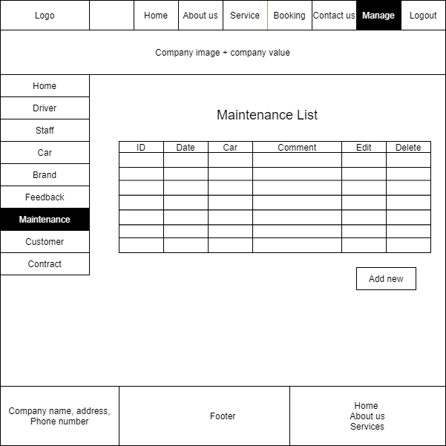

**Description:** Display the list of Maintenance information of car

**From:** [Maintenance] button from [Manage] Page

**To:** Home, About us, Service, Booking, Contact us, Driver List, Staff List, Brand List, Feedback List, Maintenance List, Customer List, Contract List, Car List, Create Maintenance, Edit Maintenance

1. **Create Maintenance**

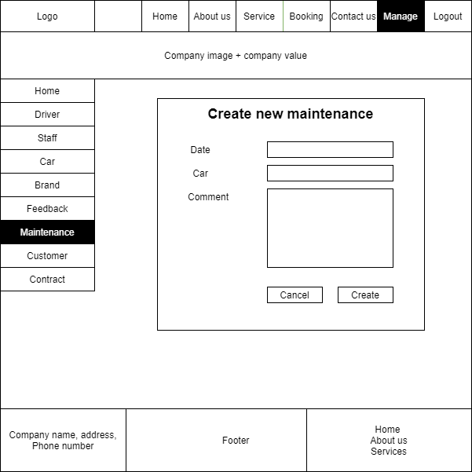

**Description:** Create a new information of Maintenance of car

**From:** [Add new] button under the [Maintenance List] table

**To:** Home, About us, Service, Booking, Contact us, Driver List, Staff List, Brand List, Feedback List, Maintenance List, Customer List, Contract List, Car List

1. **Edit Maintenance**

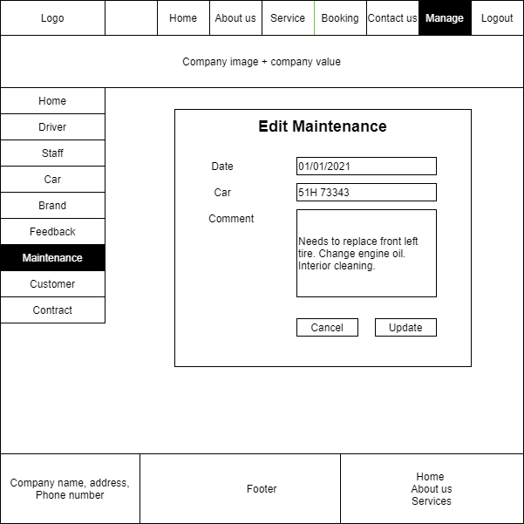

**Description:** Edit an information of Maintenance of car that has been added before

**From:** [Edit] button on [Maintenance List] table

**To:** Home, About us, Service, Booking, Contact us, Driver List, Staff List, Brand List, Feedback List, Maintenance List, Customer List, Contract List, Car List

1. **Customer List**

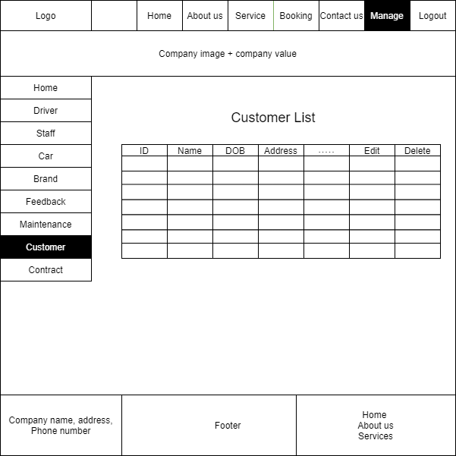

**Description:** Display the list of customer

**From:** [Customer] button from [Manage] Page

**To:** Home, About us, Service, Booking, Contact us, Driver List, Staff List, Brand List, Feedback List, Maintenance List, Customer List, Contract List, Car List

1. **Feedback List**

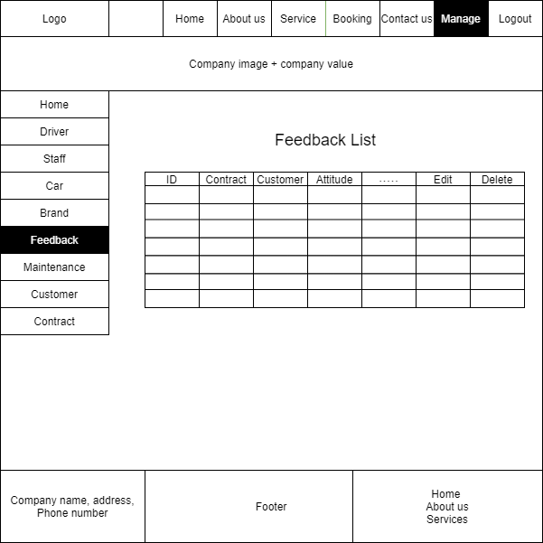

**Description:** Display the list of Feedback that is made by customer

**From: [**Feedback] button from [Manage] Page

**To:** Home, About us, Service, Booking, Contact us, Driver List, Staff List, Brand List, Feedback List, Maintenance List, Customer List, Contract List, Car List

1. **Contract List**

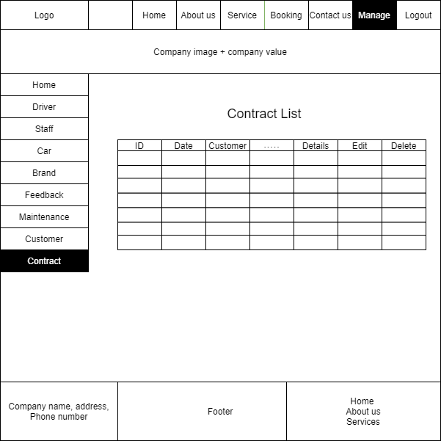

**Description:** Display the list of contract

**From: [**Contract] button from [Manage] Page

**To:** Home, About us, Service, Booking, Contact us, Driver List, Staff List, Brand List, Feedback List, Maintenance List, Customer List, Contract List, Car List

**Testing Documents**

|  |  |  |
| --- | --- | --- |
| **Sr. No.** | **Features Tested** | **Remarks** |
| 1 | Database created successfully? | Pass |
| 2 | Tables are created and migrated to database successfully? | Pass |
| 3 | Images could be inserted into database properly? | Pass |
| 4 | Data lists with images displayed properly? | Pass |
| 5 | Information of car/driver/staff/… could be updated properly? | Pass |
| 6 | Information of car/driver/staff/… could be deleted? | Pass |
| 7 | Functions in controllers are working properly? | Pass |

**Final Checklist**

|  |  |  |
| --- | --- | --- |
| **Sr. No.** | **Aspects Tested** | **Suggestion/**  **Remarks** |
| 1 | Are all the users able to view the images and links? | Passed |
| 2 | Have all views, models and controllers been properly integrated and is the site function as a single page application? | Passed |
| 3 | Are the GUI content devoid of spelling mistakes? | Passed |
| 4 | Is the application user-friendly? | Passed |
| 5 | Is the Website launching correctly in all popular browsers? | Passed |
| 6 | Are all the forms validated with proper criteria? | Passed |
| 7 | Do all texts links lead to the appropriate website? | Passed |
| 8 | Do all images links lead to the appropriate website? | Passed |
| 9 | Are all the images and links clearly visible on the pages? | Passed |
| 10 | Does the Website work properly in all tested browsers? | Passed |
| 11 | Does the Website take too long to be loaded fully? | Passed |
| 12 | Is the navigation sequences correct through all the pages on the Website? | Passed |
| 13 | Is the JavaScript code working as expected in all click events? | Passed |

**Task List**

|  |  |  |  |  |  |  |  |  |
| --- | --- | --- | --- | --- | --- | --- | --- | --- |
| **No** | **Member** | **Contents** | | **Table Name** | **Activity Plan** | **Date of Preparation of Activity Plan** | | |
| **Planed Start Date** | **Actual Start Date** | **Actual Days** | **Status** |
| 1 | **Lưu Quang Nhật** | Admin | View/ Edit/ Delete | Contract  Contract Details | 20/08/2021 | 20/08/2021 | 3 | OK |
| 2 | 20/08/2021 | 20/08/2021 | 3 | OK |
| 3 | User | Create/ View | 20/08/2021 | 20/08/2021 | 3 | OK |
| 4 | 20/08/2021 | 20/08/2021 | 3 | OK |
|  | | | |  |  | | | |
| 1 | **Nguyễn Anh Đức** | Admin | Create/ View/ Edit/ Delete | Driver  Management Staff | 20/08/2021 | 20/08/2021 | 3 | OK |
| 2 | 20/08/2021 | 20/08/2021 | 3 | OK |
| 3 | User | View | 20/08/2021 | 20/08/2021 | 3 | OK |
| 4 | 20/08/2021 | 20/08/2021 | 3 | OK |
|  | | | |  |  | | | |
| 1 | **Hoàng Anh Đức** | Admin | View/ Delete | Customer  Feedback | 20/08/2021 | 20/08/2021 | 3 | OK |
| 2 | 20/08/2021 | 20/08/2021 | 3 | OK |
| 3 | User | Register/ Edit | 20/08/2021 | 20/08/2021 | 3 | OK |
| 4 | 20/08/2021 | 20/08/2021 | 3 | OK |
|  | | | |  |  | | | |
| 1 | **Nguyễn Võ Minh Tuấn** | Admin | Create/ View/ Edit/ Delete | Car  Brand | 20/08/2021 | 20/08/2021 | 3 | OK |
| 2 | User | View | 20/08/2021 | 20/08/2021 | 3 | OK |
| 3 | Admin | Create/ View/ Edit/ Delete | Maintenance | 20/08/2021 | 20/08/2021 | 3 | OK |
| 4 | 20/08/2021 | 20/08/2021 | 3 | OK |